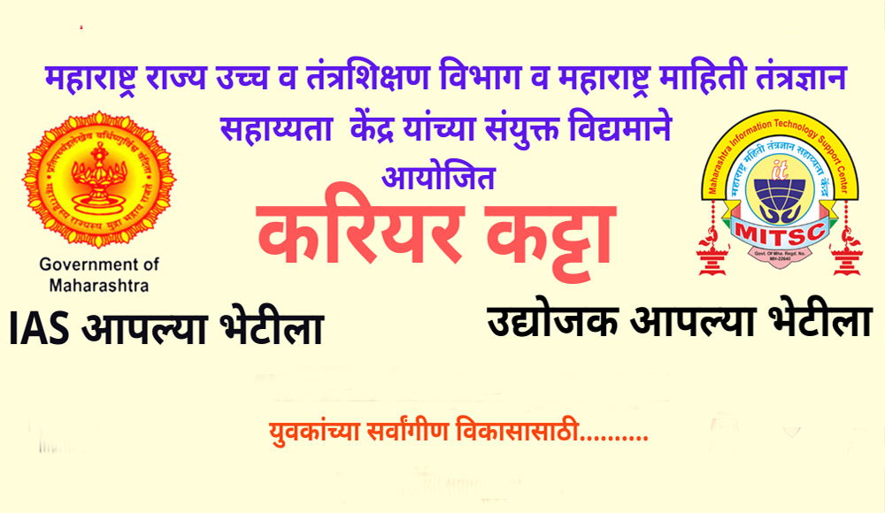

Some information which is to be put under the tab regarding “Career Katta…”

“Career Katta” is initiated jointly by the Maharashtra Information Technology Support Centre (MITSC) and Maharashtra State Higher and Technical Department. Its motto is to provide value-added skilled human resources. To develop entrepreneurial skills among the youth it has started “Udyojak Aaplya Bhetila”, and to make the burocrates and Officers it has started “IAS Aaplya Bhetila”. Only 365/- charge for three years. The tremendous video lecture provides freely through its YouTube channel. The LRC website has provided here the link of this YouTube channel named “Uva Jagar Abhiyan”.

